Chapter 2, Problem 83.

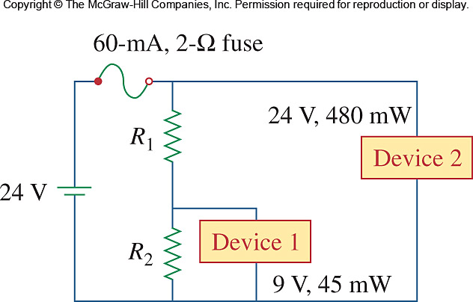
Two delicate devices are rated as shown in Fig. 2.142. Find the values of the resistors R₁ and R₂ needed to power the devices using a 24-V battery.

Figure 2.142
For Prob. 2.83.

